-- Calculate the average age of passengers who survived and those who did not

SELECT

AVG(CASE WHEN [Survived] = 1 THEN [Age] END) AS Avg_Age_Of_Survivors,

AVG(CASE WHEN [Survived] = 0 THEN [Age] END) AS Avg_Age_Of_Non_Survivors

FROM [dbo].[train_clean];



-- Find the top 5 most common titles (e.g., Mr., Mrs., Miss) among the passengers

SELECT TOP 5 [Title], COUNT(*) as No_Of_Passengers

FROM [dbo].[train_clean]

GROUP BY [Title]

ORDER BY No_Of_Passengers DESC;

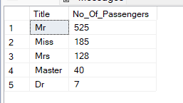

-- Calculate the average fare paid by passengers in each passenger class (Pclass)

SELECT [Pclass], AVG([Fare]) AS Avg_Fare_Paid

FROM [dbo].[train_clean]

GROUP BY [Pclass]

ORDER BY Avg_Fare_Paid DESC;

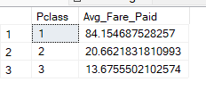

-- Retrieve passengers with the highest and lowest fare

SELECT [PassengerId], [Name], [Fare],

CASE

WHEN [Fare] = (SELECT MAX([Fare]) FROM [dbo].[train_clean]) THEN 'Highest Fare'

WHEN [Fare] = (SELECT MIN([Fare]) FROM [dbo].[train_clean]) THEN 'Lowest Fare'

END AS Fare_Type

FROM

[dbo].[train_clean]

WHERE

[Fare] = (SELECT MAX([Fare]) FROM [dbo].[train_clean] )

OR [Fare] = (SELECT MIN([Fare]) FROM [dbo].[train_clean])

ORDER BY Fare_Type;

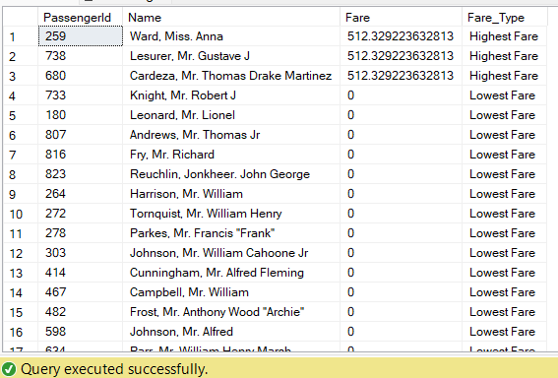

-- Find the survival rate for male and female passengers

SELECT

[Sex],

COUNT(*) AS Total_Passengers,

COUNT(CASE WHEN [Survived] = 1 THEN 1 END) AS Survived,

ROUND(100.0 * COUNT(CASE WHEN [Survived] = 1 THEN 1 END) / COUNT(*), 2) AS Survival_Rate

FROM

[dbo].[train_clean]

GROUP BY

[Sex]

ORDER BY

[Sex];

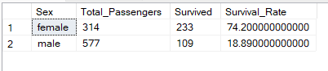

-- Calculate the average family size (SibSp + Parch + 1) for passengers who survived and those who did not

SELECT

[Survived],

AVG([SibSp] + [Parch] + 1) AS Avg_Family_Size

FROM [dbo].[train_clean]

GROUP BY [Survived]

ORDER BY [Survived];

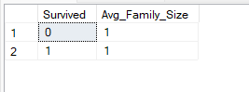

-- Retrieve the names of passengers whose age is missing (NULL)

SELECT [Name]

FROM [dbo].[train_clean]

WHERE [Age] IS NULL;

-- Find the most common port of embarkation (Embarked) and its corresponding number of passengers

SELECT TOP 1 [Embarked], COUNT(*) AS No_Of_Passengers

FROM [dbo].[train_clean]

GROUP BY [Embarked]

ORDER BY No_Of_Passengers;

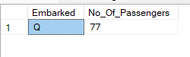

-- Calculate the average age for passengers in each passenger class and gender combination

SELECT [Pclass], [Sex], AVG([Age]) AS Avg_Passenger_Age

FROM [dbo].[train_clean]

GROUP BY [Pclass], [Sex]

ORDER BY [Pclass], [Sex];

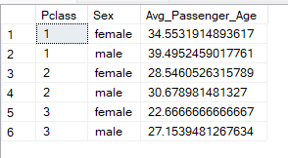

-- Retrieve passengers who were traveling alone (Family_Size = 1) and did not survive

SELECT [PassengerId],[Title], [Name], [Fare], [Sex], [Family_Size]

FROM [dbo].[train_clean]

WHERE [Family_Size] = 1

AND [Survived] = 0;

